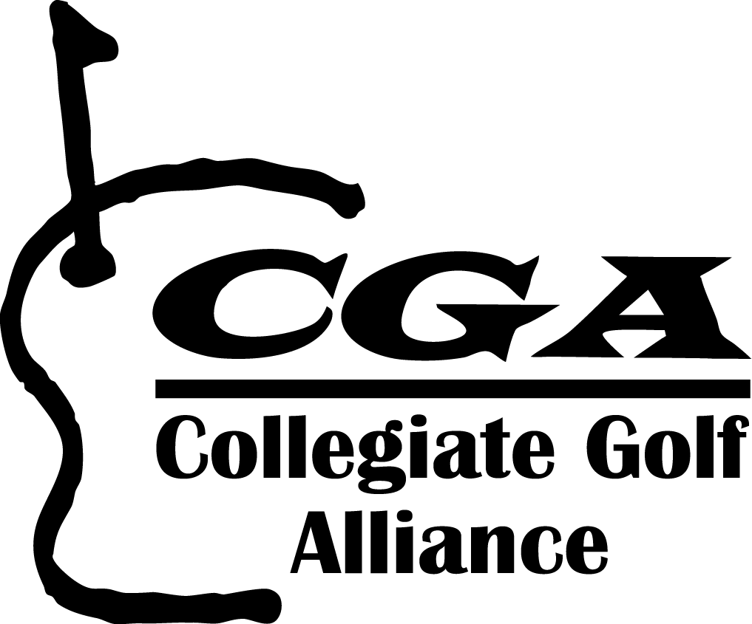 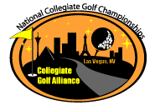 CGA Staff

President, CEO Mike Munson munson@cgagolflinks.com
Director of Business Operations Greg Long greglong@cgagolflinks.com
Sales and Communications Cindy Otte cindyotte@cgagolflinks.com
Sales & Event Management Kim Hayashi kimhayashi@cgagolflinks.com
Program Adm, LPGA An Marie Ekfeldt, anmarie@cgagolflinks.com
Program Intern Open info@cgagolflinks.com

Regional Managers

Region Manager School E-mail
Northeast Mike Croft Springfield College mcroft@spfldcol.edu
Southeast Peter Koutroumpis NC State pkoutro@gw.fis.ncsu.edu
Great Lakes John Kratzer Marquette john.kratzer@marquette.edu
Midwest Mike Widen University of Iowa michael-widen@uiowa.edu
West Mike Dominguez Sonoma State mike.dominguez@sonoma.edu

Collegiate Golf Alliance
4790 Irvine Blvd STE 105-274
Irvine, Ca 92620

413-332-6038 Phone and Fax
info@cgagolflinks.com
www.cgagolflinks.com

