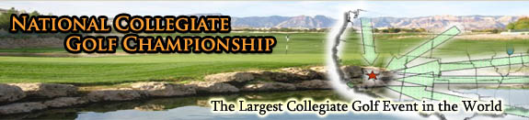

You and your campus, colleagues, and community are invited to be part of the 2010 National Collegiate Golf Championship – an amateur golf event focused on university recreational golfers and consisting of 50-80 local qualifying tournaments held across the United States. Here are just a few ways you can get involved:

Host a Local Qualifier
- Local Qualifying winners advance to the official National Collegiate Golf
- LQ Host schools receive a prize package valued at over $500 and over $50 per player.
- Register today!

Attend a Local Qualifier Near You
- Local Qualifying winners advance to the official National Collegiate Golf Championship
- Represent your school, employer, and/or community
- Click here to find an event near you!

You don’t want to miss the 2010 National Collegiate Golf Championship! This is your chance to compete with golfers from universities across the country, playing a premier course in Las Vegas, NV. This is what you have to look forward to:

2010 National Collegiate Golf Championship
- November 11-14, 2010
- Las Vegas, NV - Las Vegas Paiute Golf Club Wolf course
- 2-person scramble event for recreational golfers
- Play in one of three divisions: Student, Faculty/Staff and Alumni/Community

The NCGC program is an officially endorsed NIRSA program and has benefited the NIRSA Foundation with over $28,000 over the past 7 years. The NCGC Program is also part of the PGA PGAU program.
We’ll see you in Las Vegas!

